Project Design Phase-II
Technology Stack (Architecture & Stack)

Date | 31 January 3035
Team ID | SWTID-2026-5883
Project Name | AI WeatherWise
Maximum Marks | 4 Marks

Technical Architecture:
The Deliverable shall include the architectural diagram as below and the information as per the table1 & table 2
Example: Order processing during pandemics for offline mode
Reference: https://developer.ibm.com/patterns/ai-powered-backend-system-for-order-processing-during-pandemics/
Guidelines:
Include all the processes (As an application logic / Technology Block)
Provide infrastructural demarcation (Local / Cloud)
Indicate external interfaces (third party API’s etc.)
Indicate Data Storage components / services
Indicate interface to machine learning models (if applicable)

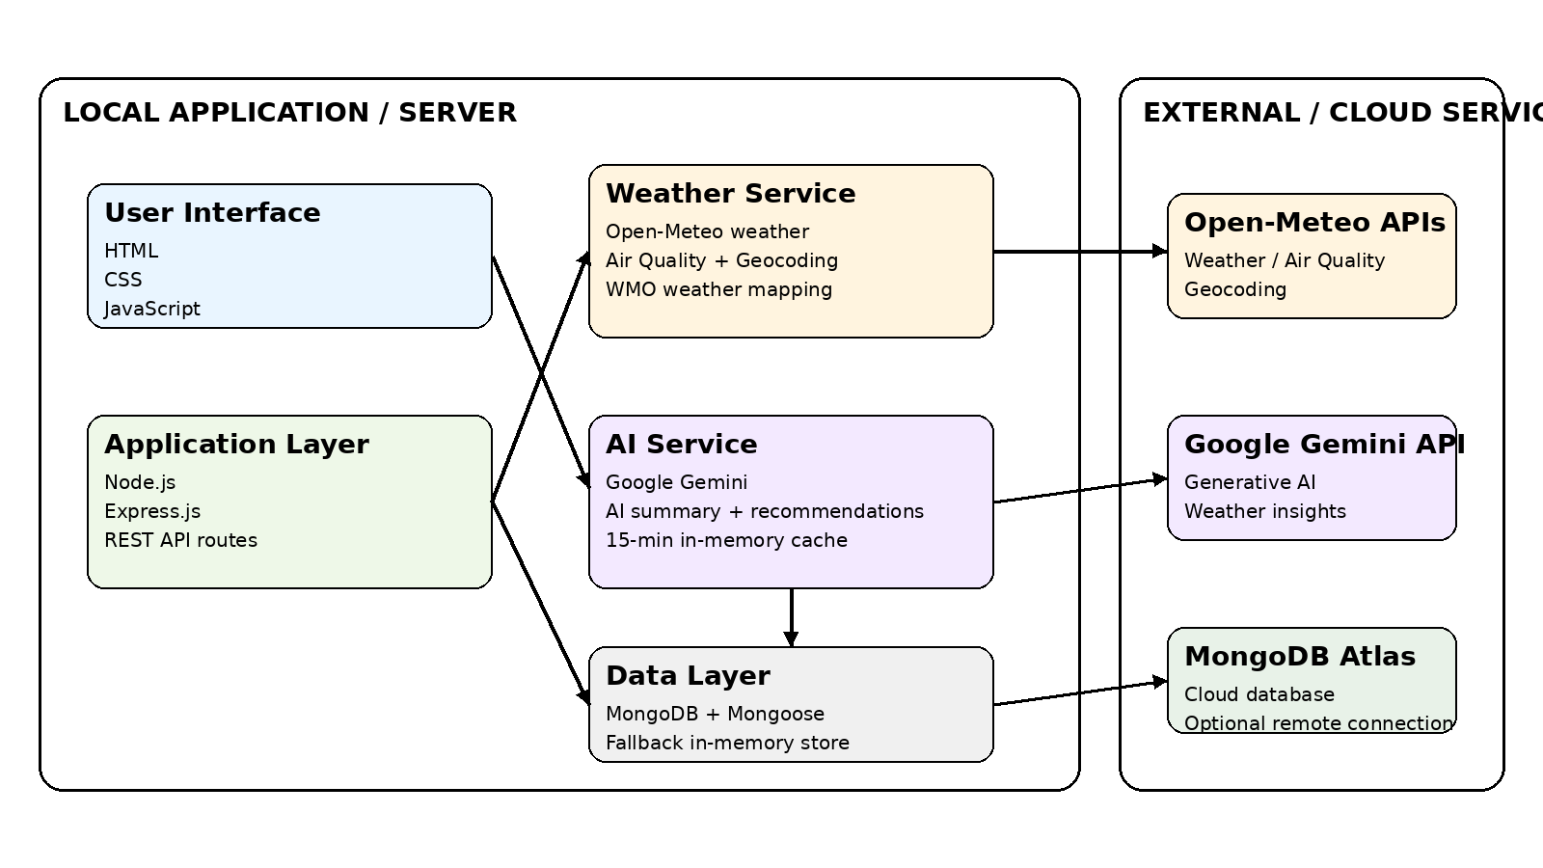

Table-1 : Components & Technologies:
S.No | Component | Description | Technology
1 | User Interface | Web-based user interface | HTML, CSS, JavaScript
2 | Application Logic-1 | Application and REST API logic | Node.js, Express.js
3 | Application Logic-2 | Real-time weather data processing and forecasting logic | JavaScript, Open-Meteo API
4 | Application Logic-3 | AI weather summary and personalized recommendation logic | Google Gemini API, @google/genai
5 | Database | User, location, post, category, comment and analytics data | MongoDB, Mongoose
6 | Cloud Database | Remote cloud database connection when configured | MongoDB Atlas
7 | File Storage | Image upload storage for application content | Local filesystem (public/uploads) using Multer
8 | External API-1 | Real-time weather, air quality and geocoding data | Open-Meteo Weather, Air Quality and Geocoding APIs
9 | External API-2 | Generative AI for weather summaries and recommendations | Google Gemini API
10 | Machine Learning Model | Natural-language weather insights and personalized recommendations | Google Gemini generative AI model
11 | Infrastructure (Server / Cloud) | Application runs on a local Node.js server; MongoDB Atlas can be used as remote cloud database | Local Node.js/Express server; MongoDB Atlas (optional)

Table-2: Application Characteristics:
S.No | Characteristics | Description | Technology
1 | Open-Source Frameworks | Open-source frameworks and packages used for web server, database access, authentication and uploads | Express.js, Mongoose, bcryptjs, jsonwebtoken, cors, multer, dotenv, @google/genai
2 | Security Implementations | JWT authentication, password hashing, role-based authorization, request sanitization and CORS controls | JWT, bcryptjs, role middleware, input sanitization, CORS
3 | Scalable Architecture | Separate user interface, application/API services and data layer; external services are integrated through APIs | HTML/CSS/JavaScript, Node.js/Express.js, MongoDB/Mongoose, REST APIs
4 | Availability | Uses resilient in-memory storage when MongoDB is unavailable and rule-based fallback when AI service is unavailable | Resilient in-memory store, AI fallback engine, external API timeout handling
5 | Performance | AI summaries and recommendations are cached for 15 minutes; external weather requests use a 7-second timeout | In-memory cache (15-min TTL), request timeout and asynchronous API calls

References:
https://c4model.com/
https://developer.ibm.com/patterns/online-order-processing-system-during-pandemic/
https://www.ibm.com/cloud/architecture
https://aws.amazon.com/architecture
https://medium.com/the-internal-startup/how-to-draw-useful-technical-architecture-diagrams-2d20c9fda90d

